SEVO
Frontend UI/UX Design Handover
Anti-Gravity Development Team • Light + Dark Theme Implementation
IMPLEMENTATION DECISION
Concept 3 = mandatory LIGHT MODE. Concept 2 = mandatory DARK MODE. Concept 1 is excluded from this handover and must not be implemented or used as a reference. Do not reinterpret the visual direction. The existing workflows, navigation, feature set, business logic and API contracts remain unchanged.

Version 1.1 • 26 August 2026

1. Purpose & Implementation Contract
EXCLUDED DESIGN: Concept 1 is intentionally not part of this specification. Do not implement, reference, compare against, or introduce Concept 1 during frontend development.
This handover is the implementation contract for the SEVO frontend redesign. It translates the approved visual direction into developer-facing tokens, components, responsive rules, interaction states, accessibility requirements, assets, rollout phases and change-control rules.
NON-NEGOTIABLE SCOPE
Redesign the presentation layer only. Existing workflows, route structure, navigation logic, permissions, forms, API behaviour, validation, booking logic and feature availability must continue to operate exactly as today.

Decision | Approved Direction
Light theme | Concept 3 — Warm & Human-Centered
Dark theme | Concept 2 — Bold & Immersive
Brand | SEVO
Primary product context | Home/service booking and service marketplace experience
Responsive target | Mobile-first; tablet and desktop supported
Accessibility target | WCAG 2.1 AA
Theme switching | System preference + in-app/manual toggle where existing settings permit
Workflow policy | No workflow or feature changes

2. Reference Image Map
The supplied/generated concept boards are the visual source of truth for the theme direction. The boards contain multiple screens; developers should use the named concept and screen labels rather than copying individual decorative details that conflict with the token system below.
REFERENCE BOARD A — Concept 3 LIGHT MODE + Concept 2 DARK MODE
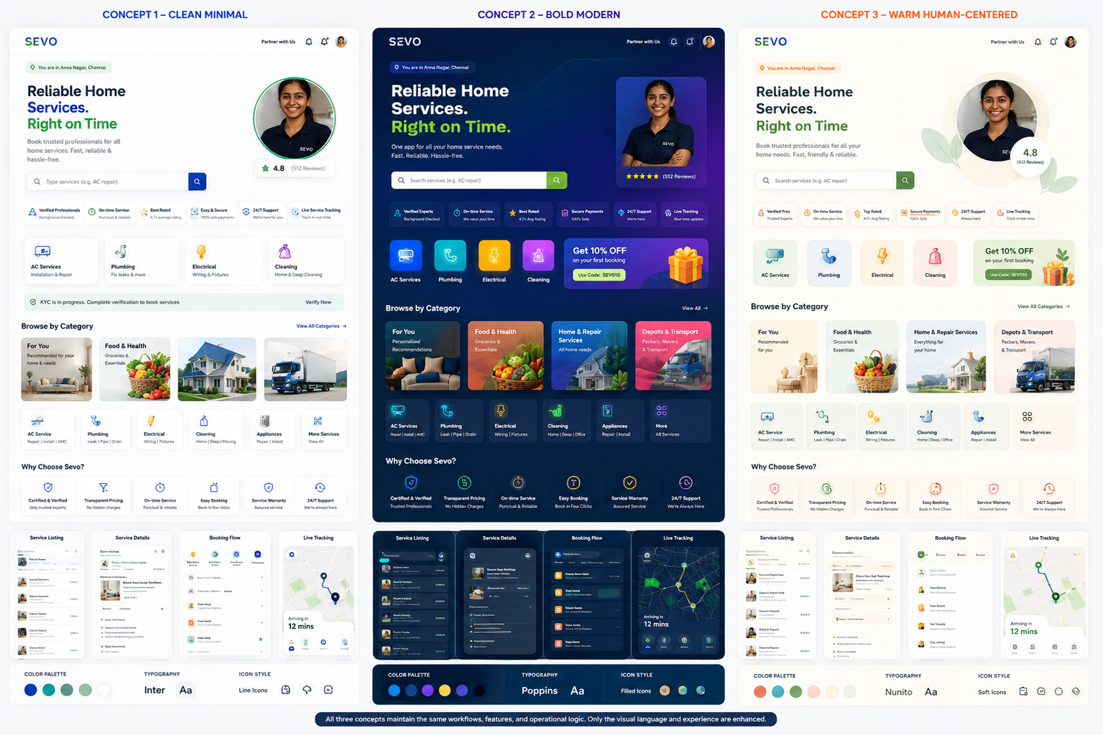
Reference ID | Theme | Use For | Priority
REF-L01 | Concept 3 / Light | Home, categories, service discovery, cards, booking flow, tracking | P0
REF-D01 | Concept 2 / Dark | Home, categories, service discovery, cards, booking flow, tracking | P0
REF-M01 | Shared structure | Same information architecture and workflow placement across themes | P0
REF-C01 | Component language | Buttons, inputs, cards, navigation, badges, states | P0

REFERENCE BOARD B — CONCEPT 3 LIGHT-MODE EMPHASIS
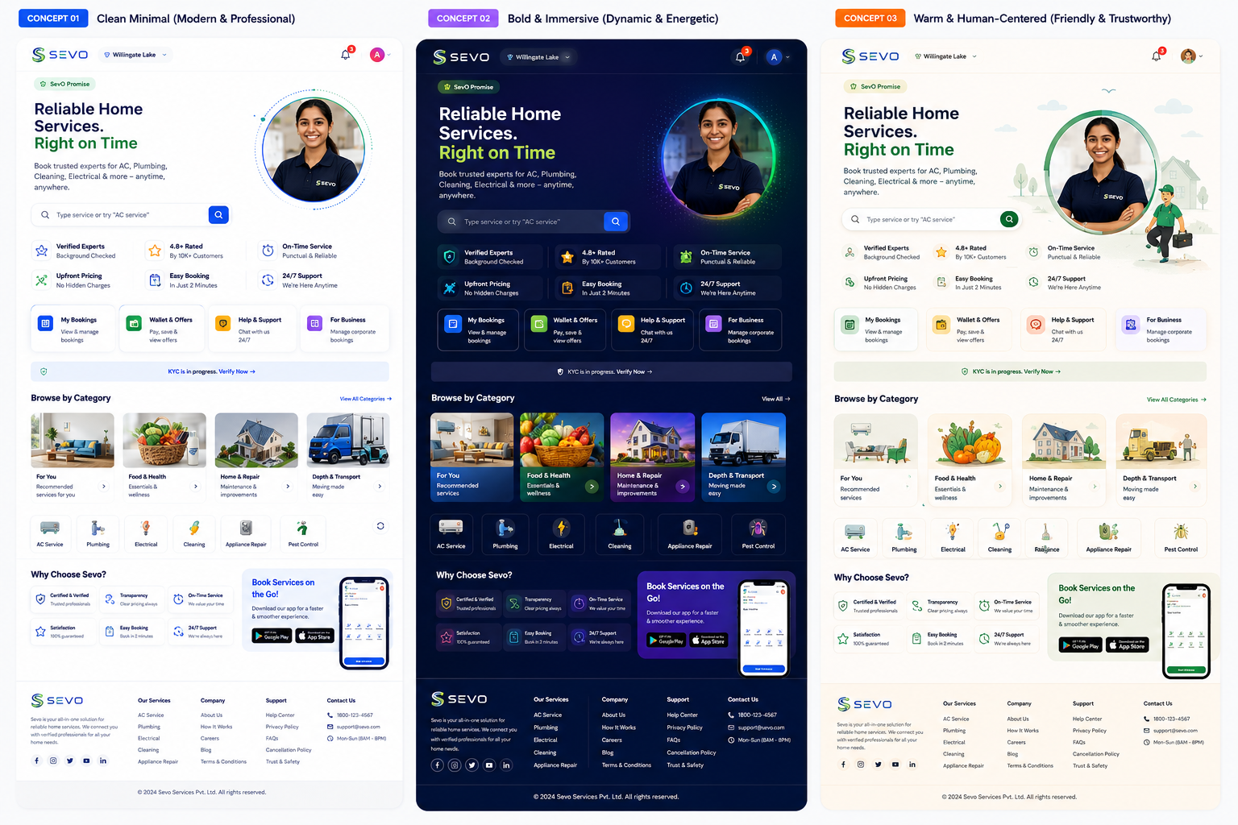
Concept 3 is the only approved light-theme source: warm off-white surfaces, restrained green accents, human imagery, soft cards and approachable service language. Concept 2 is the only approved dark-theme source: deep navy backgrounds, high-contrast surfaces, energetic blue/green accents, luminous highlights and stronger visual depth.

3. Design Token System

3.1 Core brand tokens
Token | HEX | RGB | Usage
--sevo-navy-900 | #082B5C | 8, 43, 92 | Brand/deep primary, dark surfaces
--sevo-blue-700 | #0F5FBF | 15, 95, 191 | Primary actions, links, selected states
--sevo-blue-500 | #2E80E8 | 46, 128, 232 | Interactive accents, focus, dark-mode glow
--sevo-teal-600 | #0B8F7A | 11, 143, 122 | Primary positive/service accent
--sevo-green-500 | #23B26D | 35, 178, 109 | Success, confirmation, service highlights
--sevo-lime-400 | #9BD63B | 155, 214, 59 | Selective highlight only
--sevo-ink-950 | #0B172A | 11, 23, 42 | Light-mode strongest text
--sevo-slate-600 | #475569 | 71, 85, 105 | Secondary text
--sevo-white | #FFFFFF | 255, 255, 255 | Cards, primary text on dark
--sevo-warm-50 | #FFFDF8 | 255, 253, 248 | Concept 3 page background
--sevo-warm-100 | #F8F5EE | 248, 245, 238 | Warm secondary surface

3.2 Light theme semantic tokens — Concept 3
Semantic token | Value | Usage
color.bg | #FFFDF8 | App/page background
color.surface | #FFFFFF | Cards, sheets, nav
color.surface-muted | #F8F5EE | Secondary sections
color.surface-accent | #EEF8F3 | Soft green callouts
color.text-primary | #0B172A | Headings/body primary
color.text-secondary | #475569 | Descriptions/meta
color.text-tertiary | #64748B | Hints/placeholders
color.border | #E5E7EB | Default dividers/borders
color.primary | #0B8F7A | Primary CTA
color.primary-hover | #087664 | Hover/pressed
color.secondary | #0F5FBF | Secondary action/link
color.success | #168A5B | Success
color.warning | #B7791F | Warning
color.error | #C83E3E | Error
color.focus | #2E80E8 | Keyboard/accessibility focus

3.3 Dark theme semantic tokens — Concept 2
Semantic token | Value | Usage
color.bg | #06122B | App/page background
color.surface | #0B1E43 | Primary cards/panels
color.surface-raised | #102956 | Elevated cards/modals
color.surface-muted | #0A1835 | Secondary sections
color.surface-glow | #102E62 | Selected/highlighted surfaces
color.text-primary | #F8FAFC | Headings/body primary
color.text-secondary | #CBD5E1 | Descriptions/meta
color.text-tertiary | #94A3B8 | Hints/placeholders
color.border | #24406D | Default borders
color.primary | #23B26D | Primary CTA/success
color.primary-hover | #36C77F | Hover/pressed
color.secondary | #2E80E8 | Secondary action/link
color.accent | #7C5CFF | Selective immersive accent
color.warning | #F4C95D | Warning
color.error | #FF6B6B | Error
color.focus | #69B8FF | Keyboard/accessibility focus

COLOR RULE
Do not hard-code theme-specific colors inside components. All colors must resolve through semantic theme tokens. Components should remain visually identical in structure when the theme changes.

4. Typography System
Use one consistent type family across both themes to preserve brand continuity. Preferred implementation: Inter. If the existing app already bundles a different approved font, retain the existing font family but map it to these roles.
Role | Size / Line height | Weight | Use
Display | 32 / 40 px | 700 | Hero heading
H1 | 28 / 36 px | 700 | Page title
H2 | 22 / 30 px | 700 | Section title
H3 | 18 / 26 px | 650–700 | Card/service title
Body Large | 16 / 24 px | 400–500 | Primary descriptions
Body | 14 / 20 px | 400–500 | Default body
Label | 13 / 18 px | 600 | Form labels/buttons
Caption | 12 / 16 px | 400–500 | Meta/helper text
Micro | 11 / 14 px | 500–600 | Badges/status only

5. Layout, Spacing & Responsive Rules
Token | Value | Usage
space-1 | 4 px | Icon/text micro spacing
space-2 | 8 px | Compact gaps
space-3 | 12 px | Control internal spacing
space-4 | 16 px | Default component gap
space-5 | 20 px | Card padding
space-6 | 24 px | Section/card spacing
space-8 | 32 px | Large section gap
space-10 | 40 px | Hero/major section gap
radius-sm | 8 px | Inputs/chips
radius-md | 12 px | Cards/buttons
radius-lg | 16 px | Hero/elevated cards
radius-xl | 24 px | Large sheets/feature panels

5.1 Breakpoints
Breakpoint | Viewport | Rules
Mobile | < 640 px | Single column; bottom navigation; 16 px side padding; cards stack; compact header
Tablet | 640–1023 px | 2-column service grids; persistent contextual nav where space allows; 24 px side padding
Desktop | ≥ 1024 px | Max content width 1200–1280 px; 3–4 column grids; sidebar/desktop nav where existing workflow permits
Large desktop | ≥ 1440 px | Keep content centered; do not stretch cards beyond readable widths

RESPONSIVE CONTRACT
Responsive behaviour may change layout density, column count and component sizing, but never changes the sequence of a user workflow or hides an existing feature without an equivalent accessible control.

6. Component Specifications

6.1 Buttons
Variant | Light — Concept 3 | Dark — Concept 2
Primary | Green #0B8F7A; white text; 48 px height; 12 px radius | Green #23B26D; dark navy text; 48 px height; 12 px radius
Secondary | White surface; blue border/text #0F5FBF | Navy surface; blue border/text #69B8FF
Tertiary | Transparent; navy/green text | Transparent; white/green text
Destructive | Error #C83E3E; white text | Error #FF6B6B; dark text
Disabled | Background #E5E7EB; text #94A3B8 | Background #1A2B4B; text #64748B

6.2 Inputs & Search
State | Light | Dark
Default | White surface, #E5E7EB border | #0B1E43 surface, #24406D border
Focus | 2 px #2E80E8 outer ring | 2 px #69B8FF outer ring
Error | Border #C83E3E + helper text | Border #FF6B6B + helper text
Filled | White surface + #0B172A text | #102956 + #F8FAFC text
Disabled | #F1F5F9 / muted text | #0A1835 / muted text

6.3 Cards
- Light: white cards on #FFFDF8, 1 px #E5E7EB border or very soft shadow; radius 16 px.
- Dark: #0B1E43 cards on #06122B, 1 px #24406D border; use glow sparingly for featured cards.
- Service cards must expose service name, representative image/icon, rating where available, price/from-price where available, and primary action without requiring expansion.
- Do not introduce decorative elements that compete with price, availability, booking status or primary CTA.

6.4 Navigation
- Mobile: retain existing bottom navigation structure; active item uses primary green and stronger label weight.
- Desktop/tablet: use the existing navigation logic; visual presentation may become a sidebar/top navigation if the current implementation already supports it.
- Header must keep location/context, notifications and account controls visible where currently present.
- Active navigation state must remain distinguishable without relying on color alone.

6.5 Modals, Sheets & Toasts
- Use 24 px radius for bottom sheets; 16 px for desktop dialogs.
- Backdrop: light rgba(11,23,42,.32); dark rgba(0,0,0,.56).
- Modal header must contain a clear title and accessible close button.
- Toast position must avoid bottom navigation and device safe areas.
- Error toasts must include a recovery action when one exists (Retry, Undo, View details).

7. Interaction States
State | Required behaviour
Hover | Only desktop-capable controls. Increase contrast/elevation; never rely on hover to expose essential information.
Pressed/Active | Scale ≤ 0.98 or subtle shadow reduction; immediate visual acknowledgement.
Focus | Visible 2 px focus ring plus 2 px offset; never remove outline without equivalent treatment.
Disabled | Reduce contrast while retaining WCAG-identifiable boundaries; do not use opacity alone.
Loading | Skeletons for content regions; spinner only for short blocking operations.
Empty | Human, contextual illustration + explanation + next action.
Error | Plain-language message + recovery path; preserve user-entered data where possible.
Success | Green confirmation state with concise outcome and next logical action.

8. Motion & Micro-Interaction Specification
Interaction | Timing | Motion
Button feedback | 100–140 ms | Subtle scale/brightness/elevation response
Card hover | 160–200 ms | Elevation + border/accent transition
Page transition | 200–280 ms | Fade + 8–12 px directional movement
Bottom sheet | 240–320 ms | Ease-out slide from bottom
Modal | 180–240 ms | Fade backdrop + 8 px scale/translate
Theme switch | 250–350 ms | Cross-fade surfaces/text; no flashing
Skeleton | 1200–1600 ms | Low-contrast shimmer; respect reduced-motion
Success | 350–500 ms | Checkmark draw/scale + subtle confetti only for major confirmation

REDUCED MOTION
When prefers-reduced-motion is enabled, remove parallax, shimmer, scaling and non-essential movement. Retain instant state changes and clear focus/selection feedback.

9. Accessibility Requirements
- Target WCAG 2.1 AA for all production screens.
- Normal text must achieve at least 4.5:1 contrast; large text at least 3:1.
- Interactive controls and meaningful graphical objects should meet at least 3:1 contrast against adjacent colours.
- Never communicate status through colour alone. Pair colour with icon, label, shape or text.
- Minimum touch target: 44 × 44 px. Prefer 48 × 48 px for primary controls.
- Keyboard focus must be visible on every interactive element in web/tablet/desktop contexts.
- All images require meaningful alt text when informative; decorative imagery uses empty alt text.
- Form errors must be announced/associated with the relevant field and preserve entered data.
- Support dynamic text scaling without clipping essential actions.
- Dark mode must remain readable in bright and dim conditions; avoid pure #000 backgrounds and pure #FFF body text where glare is excessive.
- Respect system reduced-motion, high-contrast and screen-reader semantics.

10. Asset Delivery Specification
Asset type | Format | Naming convention | Export
Logo | SVG + PNG | sevo-logo-[variant]-[theme] | SVG preferred; PNG @1x/@2x/@3x
Service icons | SVG | icon-service-[name] | 24/32 px viewBox
Hero/marketing image | WebP + JPG fallback | img-hero-[screen]-[name] | Optimized, max quality ~80–85
UI illustrations | SVG/WebP | illustration-[state]-[name] | Transparent where needed
App screenshots | WebP/PNG | screen-[route]-[theme] | @2x for design review
Fonts | WOFF2 | Inter-[weight] | Subset only required weights

- Use SVG for icons/logos whenever possible.
- Avoid embedding text inside raster images when the text is part of the UI.
- Provide light/dark assets only when a single vector cannot maintain adequate contrast.
- Compress raster assets and lazy-load below-the-fold imagery.

11. Screen-by-Screen Implementation Map
Screen / Flow | Light Mode | Dark Mode | Acceptance requirement
Splash / Brand | Concept 3 | Concept 2 | Logo remains high-contrast; no workflow change
Onboarding | Concept 3 | Concept 2 | Same slides/content/order
Location | Concept 3 | Concept 2 | Same permissions, saved locations and fallback
Login / OTP | Concept 3 | Concept 2 | Same validation and resend behaviour
Home / Discovery | Concept 3 | Concept 2 | Same categories, promotions, recommendations
Category / Service listing | Concept 3 | Concept 2 | Same filters/sort/search
Service detail | Concept 3 | Concept 2 | Same package/add-on information
Booking flow | Concept 3 | Concept 2 | Same date/time/address/coupon steps
Payment | Concept 3 | Concept 2 | Same payment methods and failure recovery
Booking confirmation | Concept 3 | Concept 2 | Same ID/status/details
Live tracking | Concept 3 | Concept 2 | Same map/tracking data
Completed service/review | Concept 3 | Concept 2 | Same rating/review/invoice flow
Profile / bookings | Concept 3 | Concept 2 | Same account controls
Empty/loading/error states | Concept 3 | Concept 2 | Theme-specific visual treatment only

12. Frontend Implementation Guidance
- Implement themes through a central token layer, not per-component ad-hoc colour overrides.
- Recommended model: :root semantic tokens for light mode + [data-theme='dark'] overrides for dark mode.
- Component styles consume semantic tokens only: background, surface, text, border, primary, secondary, success, warning, error, focus.
- Keep route components and business logic unchanged unless a purely presentational refactor is necessary.
- Separate content/data from presentation so theme switching never duplicates service data or workflow logic.
- Use reusable primitives: Button, Input, SearchField, ServiceCard, CategoryCard, Badge, StatusChip, Modal, BottomSheet, Toast, Skeleton, EmptyState, ErrorState, Navigation.
- Use design tokens for radius, spacing, typography and elevation so the two themes share geometry.
- Do not create separate light/dark copies of the same page. Render one page using theme tokens.

12.1 Suggested token structure
/* conceptual structure */
:root {
--color-bg: #FFFDF8;
--color-surface: #FFFFFF;
--color-text-primary: #0B172A;
--color-text-secondary: #475569;
--color-border: #E5E7EB;
--color-primary: #0B8F7A;
--color-secondary: #0F5FBF;
}
[data-theme="dark"] {
--color-bg: #06122B;
--color-surface: #0B1E43;
--color-text-primary: #F8FAFC;
--color-text-secondary: #CBD5E1;
--color-border: #24406D;
--color-primary: #23B26D;
--color-secondary: #2E80E8;
}

13. Definition of Done / QA Checklist
- Every existing route is reachable exactly as before.
- Every existing form, validation, CTA, API call and error path behaves exactly as before.
- Light mode visually matches Concept 3 direction.
- Dark mode visually matches Concept 2 direction.
- No hard-coded theme colours remain in shared UI components.
- All states exist: default, hover, pressed, focus, disabled, loading, empty, error, success.
- No horizontal overflow at supported breakpoints.
- Touch targets are ≥44 × 44 px.
- Contrast checks pass for both themes.
- Keyboard navigation and screen-reader semantics are intact where applicable.
- Reduced-motion behaviour is implemented.
- Images are optimized and lazy-loaded where appropriate.
- Theme switching does not reset form state, navigation state or user-entered data.
- Regression testing confirms no business workflow changed.

14. Recommended Phased Rollout
Phase | Scope | Priority
P0 — Foundation | Theme tokens, typography, global surfaces, buttons, inputs, navigation, accessibility base | Must ship first
P1 — Core journey | Home, categories, service listing, service detail, booking flow | Critical
P2 — Transactional | Payment, confirmation, tracking, invoices/reviews | Critical
P3 — Account & states | Profile, empty/error/loading states, support surfaces | High
P4 — Polish | Motion, advanced responsive tuning, image optimization, dark-mode refinements | High
P5 — Regression | Workflow, accessibility, visual, performance and cross-device QA | Release gate

15. Design Clarification & Escalation Path
No personal design contact details were supplied with the handover. Do not invent an individual contact. Use the following controlled escalation path during implementation:
- Create a GitHub issue in the SEVO frontend repository using the label `design-handover`.
- Include: screen/route, screenshot, theme, current implementation, expected behaviour, and blocking/non-blocking classification.
- For a blocking release issue, tag the designated Product/Design owner configured for the repository.
- Do not independently change tokens, workflow structure or component behaviour to resolve a visual ambiguity without recording the decision.
- Approved decisions must be reflected in the change log below.

16. Version Control & Change Log
Version | Date | Change | Owner | Status
1.0 | 2026-08-26 | Initial developer handover; Concept 3 light / Concept 2 dark | SEVO Product/Design | Approved baseline

Future change format:
Field | Required content
Version | Semantic version, e.g. 1.1
Date | YYYY-MM-DD
Affected theme | Light / Dark / Both
Affected tokens/components | Exact token or component names
Reason | Business/design/accessibility rationale
Migration impact | None / visual / component API / workflow risk
Approval | Design/Product owner
Status | Proposed / Approved / Implemented / Deprecated

17. Final Handover Acceptance
FINAL IMPLEMENTATION RULE
If a developer must choose between visual preference and workflow preservation, workflow preservation wins. If a developer must choose between a local component colour and the theme token system, the token system wins. Concept 3 is Light. Concept 2 is Dark. Both are one shared SEVO product experience.

SEVO • UI/UX Design Handover • v1.1

